**D.K.T.E. Society’s Textile and Engineering Institute,**

**Ichalkaranji**

(An Autonomous Institute, Affiliated to Shivaji University, Kolhapur)

Accredited with ‘A ’Grade by NAAC

**Department of Computer Science & Engineering**

**2022-2023**



## THE SRS AND DESIGN DOCUMENT ON

**“Secure-Vote”**

Under the guidance Of

**Mrs. Prof. Jayamala Madam**

# Submitted By:

**Rushikesh Giri 20UCS055**

# Rohnit Kabade 20UCS062

**Pranav Kamble 20UCS065**

# Pranav Karadage 20UCS070

Have successfully completed the SRS and Design work, of the mini project entitled

**“Secure-Vote”**

In partial fulfillment for T.Y. B. Tech CSE academics. This is the record of their work carried out during academic year 2022-2023.

# Date:

**Place:** Ichalkaranji

Mrs. Prof. Jayamala Madam Prof. Dr. D.V. Kodavade

# [Project Guide] [HOD]

**DECLARATION**

We the undersigned students of T.Y.C.S.E. declare that the Project work report entitled “Secure-Vote” written and submitted under the guidance of Mrs. Prof. Jayamala is our original work. The empirical findings in this report are based on the data collected by us. The matter assimilated in this report is not reproduction from any readymade report.

Date:

Place: Ichalkaranji

|  |  |
| --- | --- |
| Name | Signature |

Rushikesh Giri 20UCS055

Rohnit Kabade 20UCS062

Pranav Kamble 20UCS065

Pranav Karadage 20UCS070

**SYNOPSIS**

# INDEX

|  |  |  |
| --- | --- | --- |
| **Sr. No** | **Table of contents** | **Page no.** |
| 1. | Introduction | 1 |
| **2.** | Literature Review | 2 |
| 3. | Problem Statement/Objective | 3 |
| 4. | Proposed Methodology | 4 |
| 5. | Block Diagram | 5 |
| 6. | Facilities required for Proposed Work | 6 |
| 7. | Conclusion | 7 |
| 8. | References | 8 |

**INTRODUCTION**

India has democratic government. As now all Indian citizens become a part of the growing digital India. They have a digital ID that is Aadhaar card. Voting schemes have evolved from counting hands in early days to systems that include paper, punch card, electronic voting machine. An electronic voting system which is used nowadays provide some characteristic different from the traditional voting technique, and also it provides improved features of voting system over traditional voting system such as accuracy, convenience, flexibility, privacy, verifiability and mobility.

But Electronic voting systems suffers from various drawbacks such as time consuming, consumes large volume of paperwork, no direct role for the higher officials, damage of machines due to lack of attention, mass update doesn’t allow users to update and edit many items simultaneously etc. These drawbacks can overcome by Online Voting System. This is a voting system by which any voter can use his/her voting rights from anywhere in the country. Voter can cast their votes from anywhere in the country without visiting to voting booths, in highly secured way. That makes voting a fearless of violence and that increases the percentage of voting.

# LITERATURE REVIEW

To make the voting process very easy and efficient wireless and web technologies are used. The online- voting system has the possibility of secure, easy and safe way to capture and countthe votes in the election. The author in online voting system based on Aadhaar id” uses Aadhaar id as key of authentication, system is efficient in terms of time and provides security the system is great improvement over traditional system, but the main problem resides in this system is that of authentication, the authentication technique used is not that efficient as biometric is not used.

|  |  |  |  |  |  |
| --- | --- | --- | --- | --- | --- |
| **Sr.**  **No** | **System** | **Communication**  **Interface** | **User**  **Interface** | **Applications** | **Benefits** |
| **1.** | Web-Based- Voting. handy Hussein, et al. IEEE 2013. | Web-Browser | Web-Based Application | Online | 1. Eligibility 2. Uniqueness 3. Efficient |
| **2.** | Blockchain- voting Geetanjali Rathee March 4,2021 | Server-Client Interface | IOT oriented smart devices | Online | 1. All the entities involved have access 2. Reliable |
| **3.** | E-Voting system Faisalabad  2019 | window based application | GUI | Online suggestion s. | a)Ease of access b)Remote Availability |
| **4.** | E-voting | Server-client Interface | Web-Based Application | Online | 1. Easyto use 2. Simpler Interface |

# PROBLEM STATEMENT/OBJECTIVE

### Problem Statement: -

The Existing System of Election is running manually. The Voter has to Visit to Booths to Vote a Candidate so there is. wastage of Time. The Voter has to manually register into the Voter List. Also, Vote counting has to be done manually. All the Information of the Voter or Candidate is to be filling in manually. Voter must be present in his/her Constituency to give his/her Vote.

### Objective: -

* Increasing number of voters as individuals will find it easier and more convenient to vote.
* Less effort and less labor intensive, as the primary cost and focus primary on creating, managing, and running a secure web voting portal.
* The system can be used anytime and from anywhere by the Voters.
* No one can cast votes on behalf of others and multiple times.
* Saves time and reduces human intervention.
* The system is flexible and secured to be used.
* Unique Identification of voter through Aadhar number.
* Improves voting with friendly Interface.
* No fraud vote can be submitted.

# PROPOSED METHODOLOGY

* **Login**: - Candidate need to login with their Registered Account to start using our system.
* **Vote**: - Candidate is needed to click on vote for being in voting process.
* **Aadhaar number**: Candidate needs to write their Aadhaar number.
* **Submit**: -When they try to enter Aadhaar number, their credentials will be stored in our existing database.
* **Reset**: Back to Login portal.
* **Eligible for voting**: -Candidate voted successfully.

# BLOCK DIAGRAM

LOGIN

AUTHENTICATION PROCESS

AADHAAR

NUMBER

PORTAL

YES NO

ELIGIBL- E FOR VOTING

SUBMIT

RESET

Fig: - Block diagram of Secure Vote

## FACILITIES REQUIRED FOR PROPOSED WORK

### Hardware:

* + Microsoft Windows Professional /Windows 10:
  + Processor: 800MHz Intel Pentium III or equivalent Memory: 512 MB
  + Disk space: 750 MB of free disk space

### Software:

1. Operating System: Windows 10
2. Language: HTML
3. Database: Oracle
4. Tool: HTML and CSS, Notepad

# CONCLUSION

Online Voting Systems have many advantages over the traditional voting system. Some of these advantages are less cost, faster generation results, easy accessibility, accuracy, and low risk of human and mechanical errors. It is very difficult to develop online voting system which can allow security and privacy on the high level.

Future development focused to design a system which can be easy to use and will provide security and privacy of votes on acceptable level by proper authentication and processing section. It is easy to use and it is less time consuming. It is very easy to debug.

# REFERENCES

1. Design of a secured e-voting Publisher: IEEE <https://ieeexplore.ieee.org/document/6521985>
2. Geetanjali Rathee, Razi Iqbal(Senior Member, IEEE),Omer Waqar (Member, IEEE), and Ali Kashif Bashir, (Senior Member, IEEE)

[https://www.studocu.com/in/document/jk-lakshmipat-university/computer- science-](https://www.studocu.com/in/document/jk-lakshmipat-university/computer-science-and-engineering/on-the-design-and-implementation-of-a-blockchain-enabled-e-voting-application-within-io-t-oriented-smart-cities/27264885) [and-engineering/on-the-design-and-implementation-of-a-blockchain-enabled-e-](https://www.studocu.com/in/document/jk-lakshmipat-university/computer-science-and-engineering/on-the-design-and-implementation-of-a-blockchain-enabled-e-voting-application-within-io-t-oriented-smart-cities/27264885) [voting-application-within-io-t-oriented-smart-cities/27264885](https://www.studocu.com/in/document/jk-lakshmipat-university/computer-science-and-engineering/on-the-design-and-implementation-of-a-blockchain-enabled-e-voting-application-within-io-t-oriented-smart-cities/27264885)

This work is licensed under a creative common attribution 4.0 VOLUME 9,2021

34165

1. Government college university Faisalabad Course Information Technology Academic Year 2019/2022.IEEE.

<https://www.studocu.com/in/document/government-college-university-> [faisalabad/information-technology/documentation-e-voting-system/31410607](https://www.studocu.com/in/document/government-college-university-faisalabad/information-technology/documentation-e-voting-system/31410607)

# INDEX

|  |  |
| --- | --- |
| **CONTENTS** | **PAGE NO.** |
| 1. Abstract | 1 |
| 2. Introduction | 2 |
| 3. Problem Statement | 3 |
| 4. Problem Description | 3 |
| 5. Requirement Specification | 4 |
| 6. Requirement Analysis | 5 |
| 7. Problem Solution | 6 |
| 8. Flowcharts | 7 |
| 9. Implementation | 10 |
| 10. Snapshot | 14 |
| 11. Conclusion | 18 |
| 12. References | 19 |

**ABSTRACT**

The project is mainly aimed at providing a secured and user-friendly Online Voting System. The problem of voting is still critical in terms of safety and security. This system deals with the design and development of a web-based voting system using fingerprint and Aadhaar card in order to provide a high performance with high security to the voting system.

The proposed Online Voting System allows the voters to scan their fingerprint, which is then matched with an already saved image within a database that is retrieved from Aadhaar card database of the government. The voting system is managed in a simpler way as all the users must login by Aadhaar card number and click on his/her favorable candidates to cast the vote by using biometric fingerprint it provides enough security which reduces the dummy votes.

**Keywords:** Online voting system, Online election system, AADHAAR based online election.

# INTRODUCTION

India has democratic government. As now all Indian citizens become a part of the growing digital India. They have a digital ID that is Aadhaar card. Voting schemes have evolved from counting hands in early days to systems that include paper, punch card, electronic voting machine. An electronic voting system which is used nowadays provide some characteristic different from the traditional voting technique, and also it provides improved features of voting system over traditional voting system such as accuracy, convenience, flexibility, privacy, verifiability and mobility.

But Electronic voting systems suffers from various drawbacks such as time consuming, consumes large volume of paperwork, no direct role for the higher officials, damage of machines due to lack of attention, mass update doesn’t allow users to update and edit many item simultaneously etc. These drawbacks can overcome by Online Voting System. This is a voting system by which any voter can use his/her voting rights from anywhere in the country. Voter can cast their votes from anywhere in the country without visiting to voting booths, in highly secured way. That makes voting a fearless of violence and that increases the percentage of voting.

# PROBLEM STATEMENT

Build a Secure Vote Website System through which Voters can Vote Anywhere, anytime.

# PROBLEM DESCRIPION

The Problem is that voters are unable to vote from anywhere they have to go different government centers for voting purpose.

Voter faces problems like:

* Have to travel long distance for voting.
* Have to give specific time for voting not of their desired time.
* Tempering of voters may occur.
* Forced vote may occur.

-

Voters Details and vote for Candidate.

# INPUT

Voting Process Successfully Executed.

# OUTPUT

**REQUIREMENT SPECIFICATION**

### Hardware:

* + - Microsoft Windows Professional /Windows 10:
    - Processor: 800MHz Intel Pentium III or equivalent Memory: 512 MB
    - Disk space: 750 MB of free disk space

### Software:

1. Operating System: Windows 11
2. Language: HTML
3. Database: Oracle
4. Tool: HTML and CSS, Notepad

# REQUIREMENT ANALYSIS

STEP 1: Enter Details Below

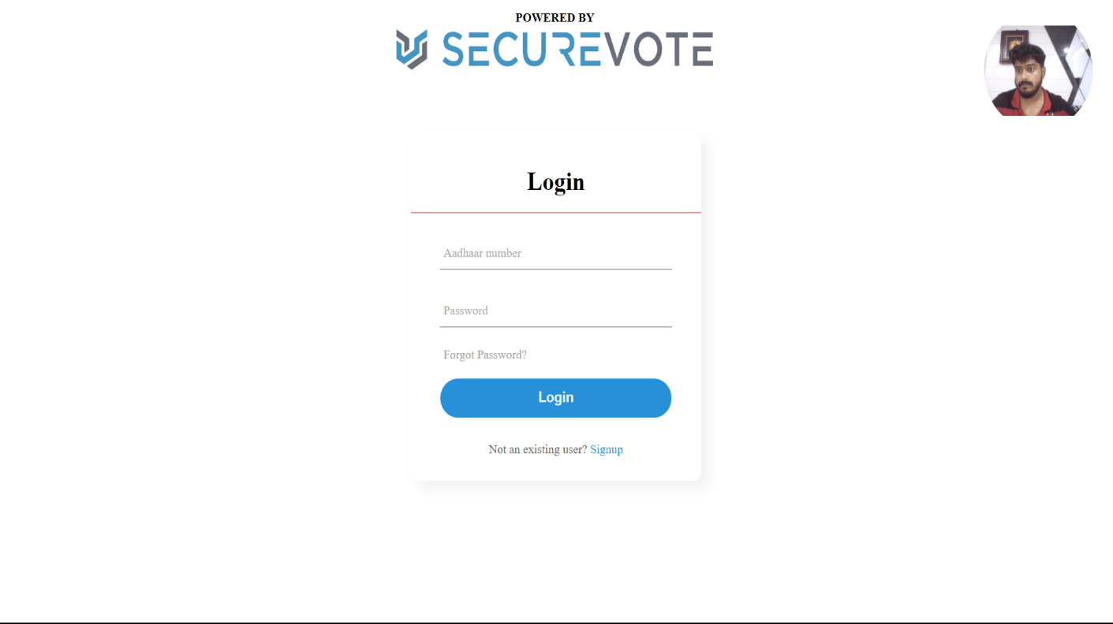

STEP 2: Main Page

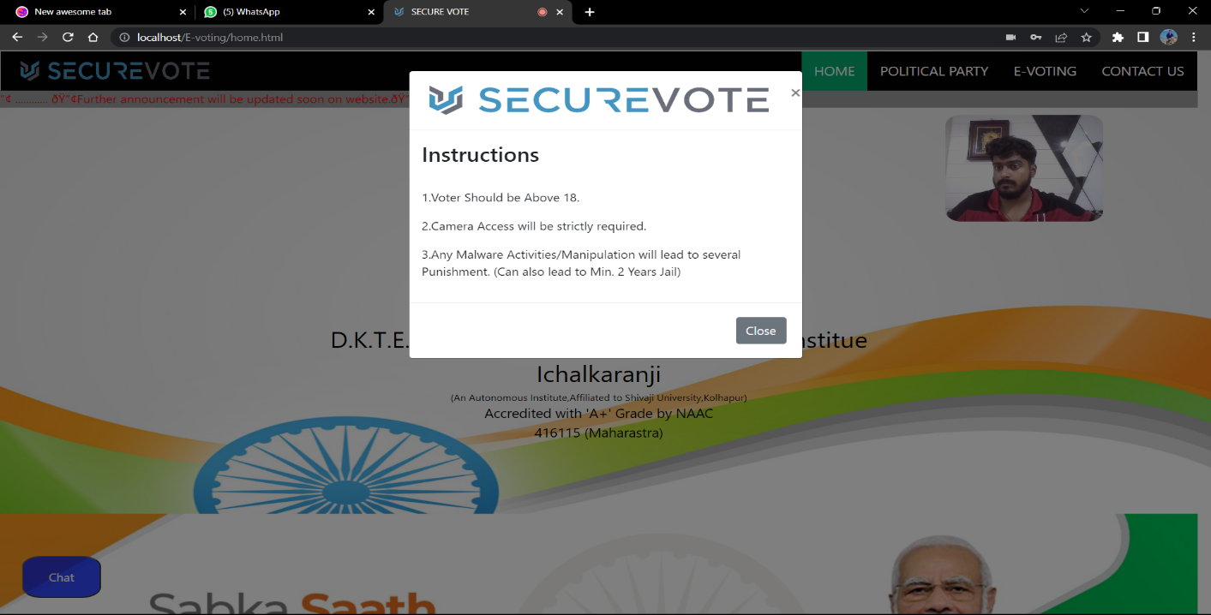

# PROBLEM SOLUTION

**Algorithm**:

1. Begin
2. Open the website for Secure Vote.

.

1. Type Basic Information.
2. Select the candidate whom to vote.
3. Click on ‘SUBMIT’ Button if all the information and vote is correct.
4. If NO Click on ‘RESET’ Button.
5. If YES Click on ‘SUBMIT’.
6. End.

# UML DIAGRAM



LOGIN

VOTE

USER

ADMIN

DETAILS

Fig: - UML Diagram of Secure Vote

# ACTIVITY DIAGRAM



LOGIN

USER

ADMIN

CHOOSE THE CANDIDATE

ADD THE CANDIDATE

LOGOUT

Fig: - Activity Diagram of Secure Vote

# BLOCK DIAGRAM

LOGIN

AUTHENTICATION PROCESS

AADHAAR

NUMBER

PORTAL.

YES NO

ELIGIBL- E FOR VOTING

SUBMIT

RESET

Fig: - Block diagram of Secure Vote

# IMPLEMENTATION

<html lang="en" dir="ltr">

<head>

    <meta charset="utf-8">

    <title> SECURE VOTE

    </title>

    <link rel="icon" href="images/logo.png">

    <style>

        .center {

            position: absolute;

            top: 50%;

            left: 50%;

            transform: translate(-50%, -50%);

            width: 400px;

            background: white;

            border-radius: 10px;

            box-shadow: 10px 10px 15px rgba(0, 0, 0, 0.05);

        }

        .center h1 {

            text-align: center;

            padding: 20px 0;

            border-bottom: 1px solid rgb(228, 8, 8);

        }

        .center form {

            padding: 0 40px;

            box-sizing: border-box;

        }

        form .txt {

            position: relative;

            border-bottom: 2px solid #adadad;

            margin: 30px 0;

        }

        .txt input {

            width: 100%;

            padding: 0 5px;

            height: 40px;

            font-size: 16px;

            border: none;

            background: none;

            outline: none;

        }

        .txt label {

            position: absolute;

            top: 50%;

            left: 5px;

            color: #adadad;

            transform: translateY(-50%);

            font-size: 16px;

            pointer-events: none;

            transition: .5s;

        }

        .txt input:focus~label,

        .txt input:valid~label {

            top: -5px;

            color: #2691d9;

        }

        .txt input:focus~span::before,

        .txt input:valid~span::before {

            width: 100%;

        }

        .pass {

            margin: -5px 0 20px 5px;

            color: #a6a6a6;

            cursor: pointer;

        }

        .pass:hover {

            text-decoration: underline;

        }

        input[type="submit"] {

            width: 100%;

            height: 50px;

            border: 1px solid;

            background: #2691d9;

            border-radius: 25px;

            font-size: 18px;

            color: #e9f4fb;

            font-weight: 700;

            cursor: pointer;

            outline: none;

        }

        input[type="submit"]:hover {

            border-color: #2691d9;

        }

        .signup_link {

            margin: 30px 0;

            text-align: center;

            font-size: 16px;

            color: #666666;

        }

        .signup_link a {

            color: #2691d9;

            text-decoration: none;

        }

        .signup_link a:hover {

            text-decoration: underline;

        }

        #container {

            margin: 0px auto;

            width: 500px;

            height: 375px;

            border: 10px#65656533;

        }

        #videoElement {

            width: 150px;

            height: 150px;

            background-color: #d2d2d2;

            border-radius: 50%;

            float: right;

            background-image: url('images/profile.png');

            background-size: cover;

            margin-right: 20px;

        }

    </style>

</head>

<body>

            <div id="container-fluid">

                <video autoplay="true" id="videoElement">

                </video>

            </div>

          <script>

                let video = document.querySelector("#videoElement");

                if (navigator.mediaDevices.getUserMedia) {

                    navigator.mediaDevices.getUserMedia({ video: true })

                    .then(function (stream) {

                        video.srcObject = stream;

                    })

                    .catch(function (error) {

                        console.log("Something went wrong!");

                    })

                }else {

                        console.log("getUserMedia not supported!");

                    }

            </script>

    <div class="center">

        <h1>Login</h1>

        <form action="login.php" method="post">

            <div class="txt">

                <input type="txt" id="Aadhaar" class="form-control" name="Aadhaar" required>

                <label for="Aadhaar" >Aadhaar number </label>

            </div>

            <div class="txt">

                <input type="password" id="password" class="form-control" name="password" required>

                <label for="password">Password</label>

            </div>

            <div class="pass">Forgot Password?</div>

            <input type="submit" value="Login" name="">

            <div class="signup_link">

                Not an existing user? <a href="signup.html">Signup</a>

            </div>

        </form>

    </div>

    <center>

        <h4 style="margin-top: 25px; margin-bottom: 0px; margin-left: 11%;">POWERED BY</h4>

    </center>

    <center><img src="images/e-voting.png" height=8% width=30% style=" margin-left: 11%;margin: top 10px; ; margin-bottom: 5px;">

    </center>

</body>

</html>

# SNAP SHOT (Back-End)

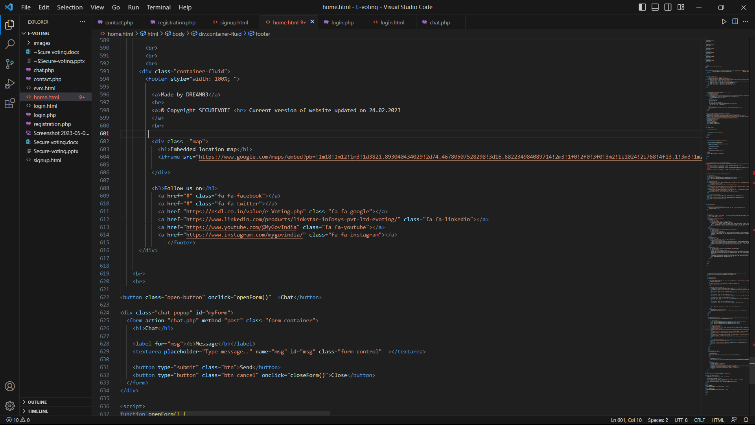

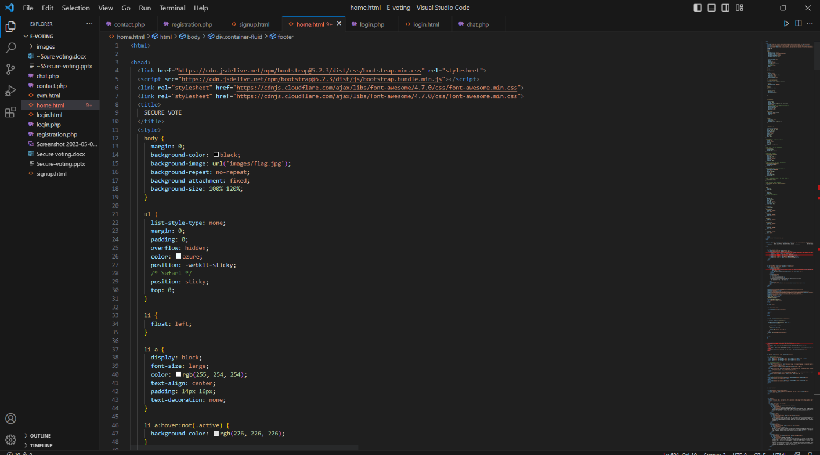

**SNAP SHOT (Front-End)**

# Step1: Login Details

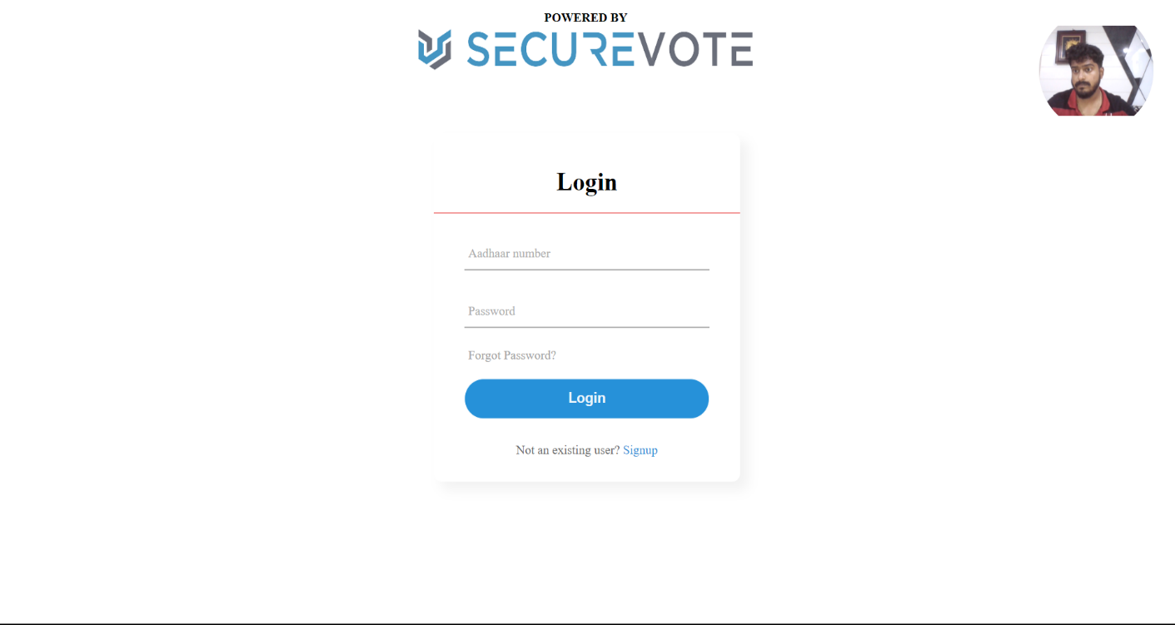

**Step2: Portal**



# Step3:service

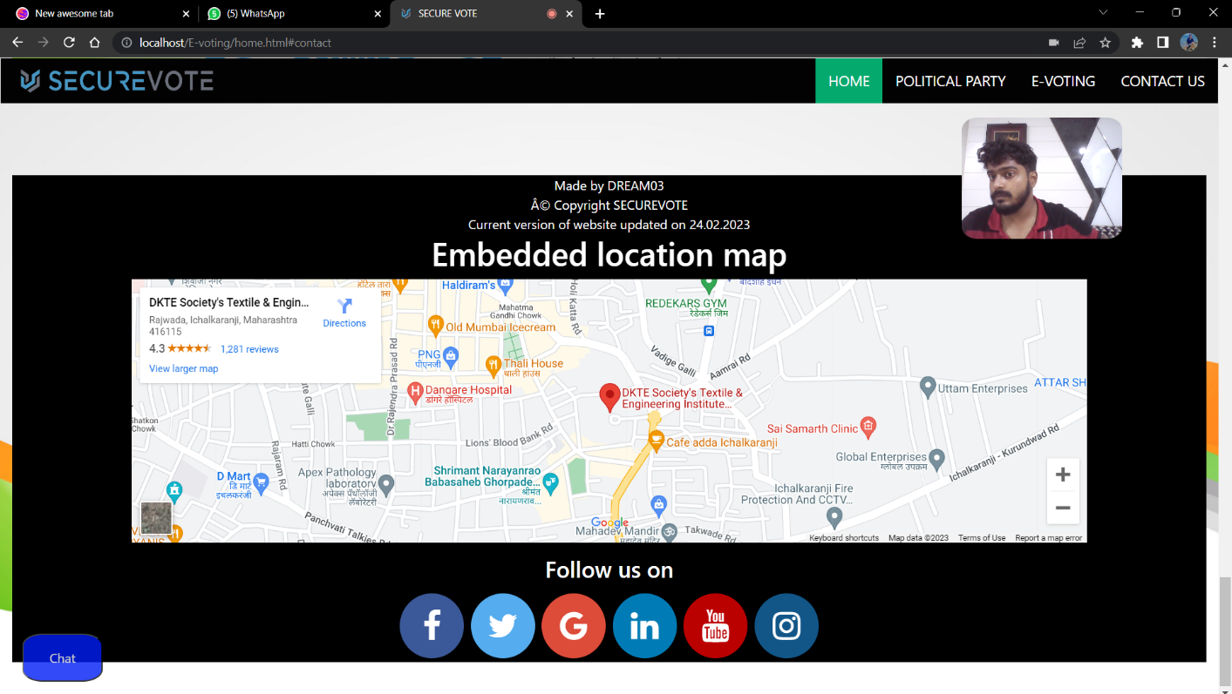

**Step4: Election**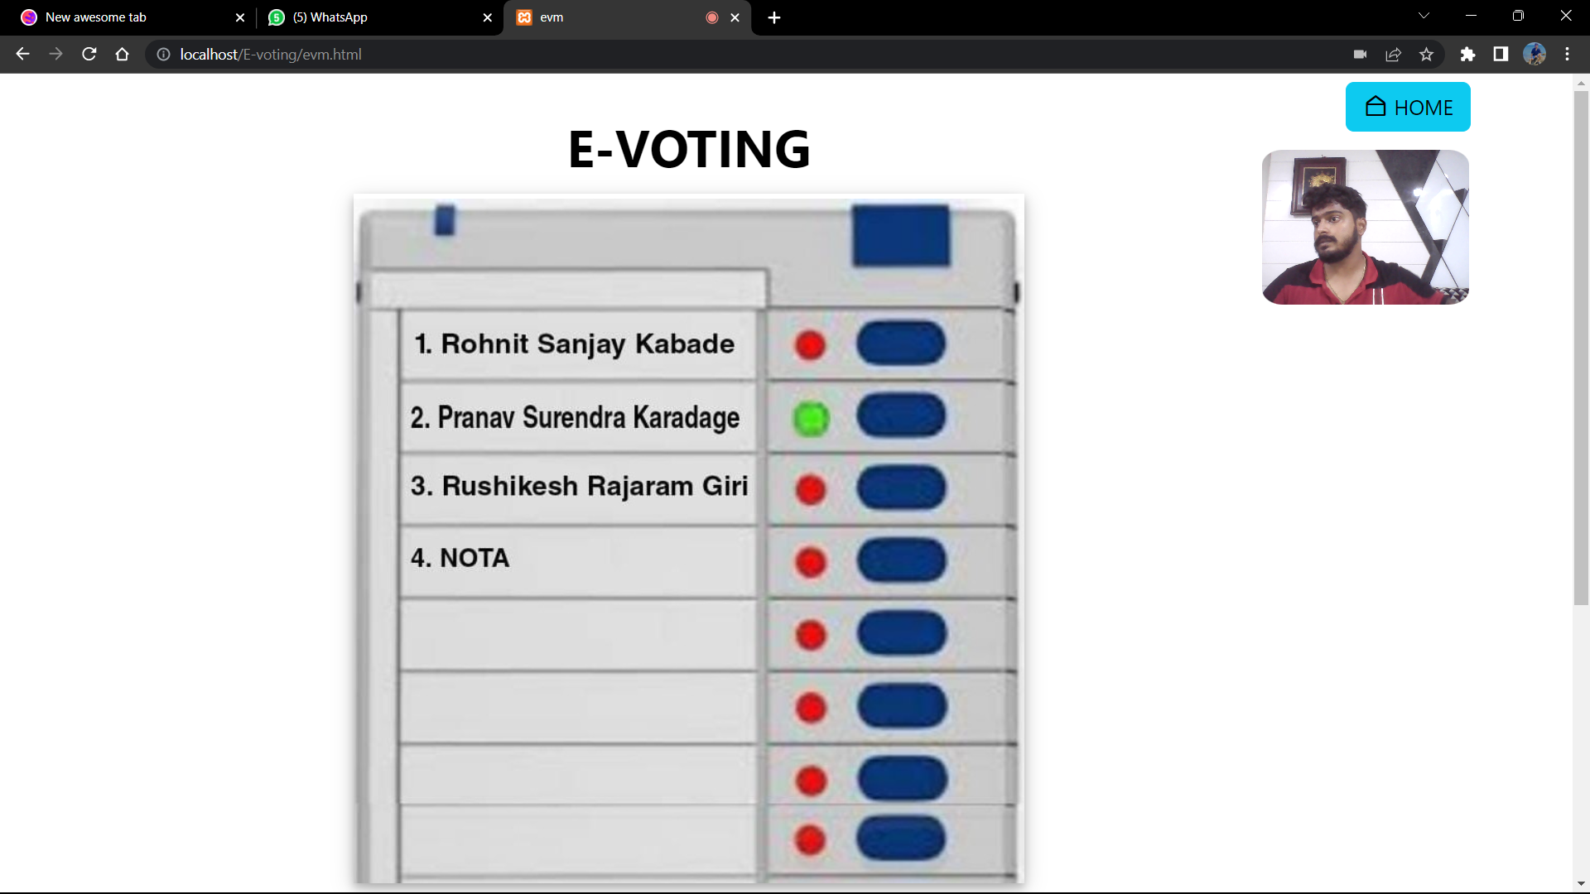

**Step5: Database**

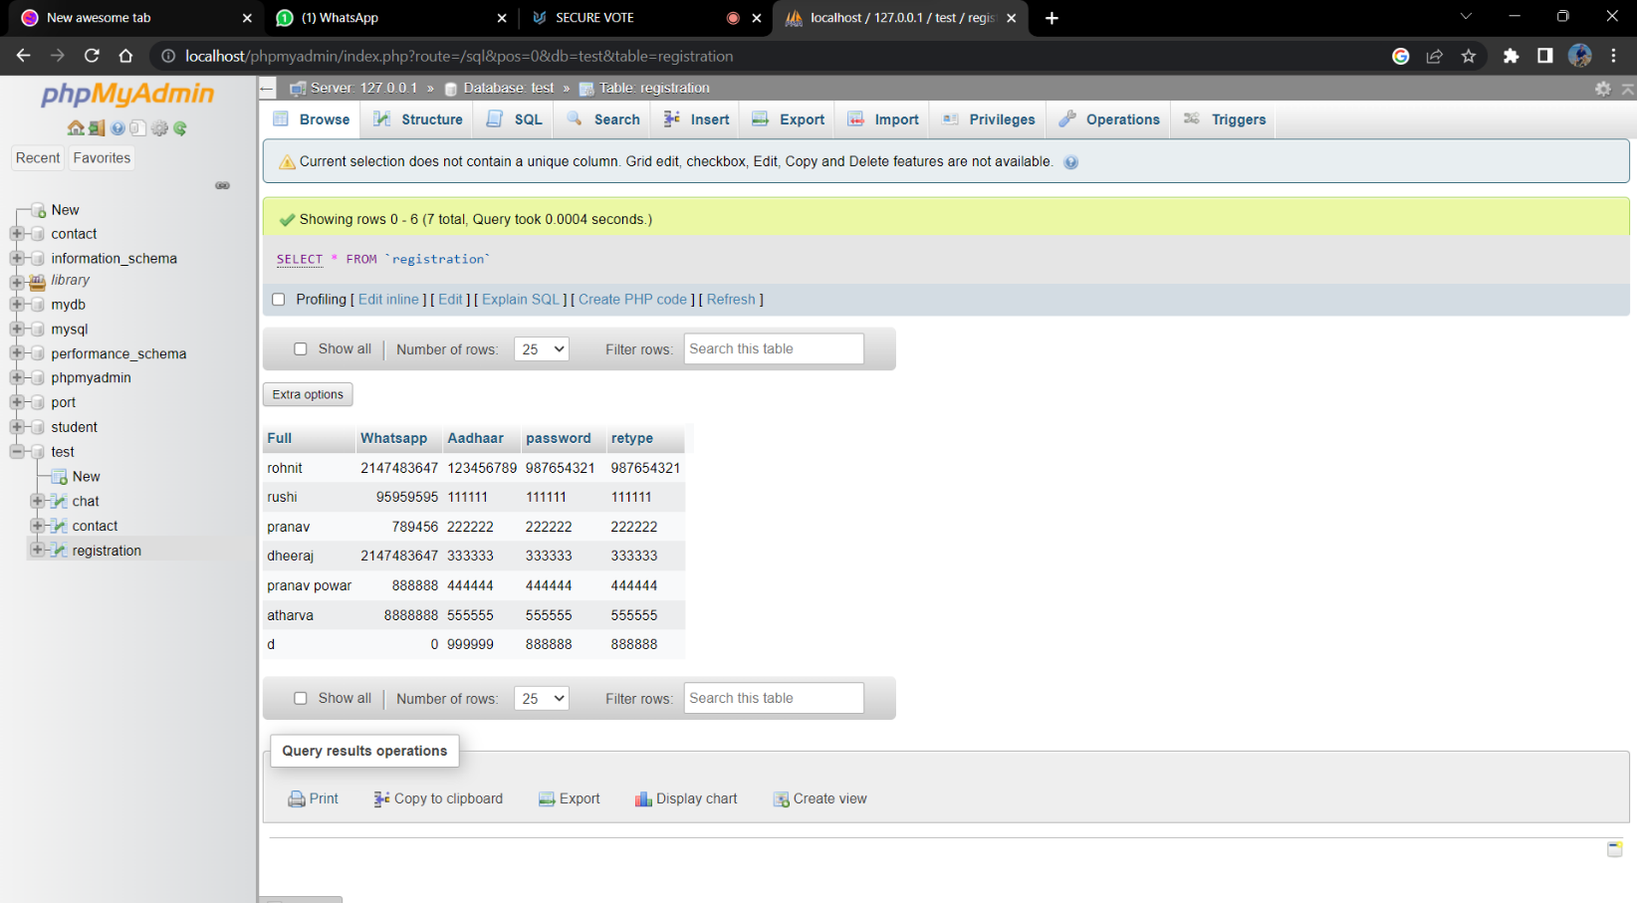

# CONCLUSION

Online Voting Systems have many advantages over the traditional voting system. Some of these advantages are less cost, faster generation results, easy accessibility, accuracy, and low risk of human and mechanical errors. It is very difficult to develop online voting system which can allow security and privacy on the high level.

Future development focused to design a system which can be easy to use and will provide security and privacy of votes on acceptable level by proper authentication and processing section. It is easy to use and it is less time consuming. It is very easy to debug.

# REFERENCES

* 1. Design of a secured e-voting Publisher: IEEE <https://ieeexplore.ieee.org/document/6521985>
  2. Geetanjali Rathee, Razi Iqbal (Senior Member, IEEE), Omer Waqar (Member, IEEE), and Ali Kashif Bashir, (Senior Member, IEEE)

[https://www.studocu.com/in/document/jk-lakshmipat-university/computer- science-](https://www.studocu.com/in/document/jk-lakshmipat-university/computer-science-and-engineering/on-the-design-and-implementation-of-a-blockchain-enabled-e-voting-application-within-io-t-oriented-smart-cities/27264885) [and-engineering/on-the-design-and-implementation-of-a-blockchain-enabled-e-](https://www.studocu.com/in/document/jk-lakshmipat-university/computer-science-and-engineering/on-the-design-and-implementation-of-a-blockchain-enabled-e-voting-application-within-io-t-oriented-smart-cities/27264885) [voting-](https://www.studocu.com/in/document/jk-lakshmipat-university/computer-science-and-engineering/on-the-design-and-implementation-of-a-blockchain-enabled-e-voting-application-within-io-t-oriented-smart-cities/27264885) [application-within-io-t-oriented-smart-cities/27264885](https://www.studocu.com/in/document/jk-lakshmipat-university/computer-science-and-engineering/on-the-design-and-implementation-of-a-blockchain-enabled-e-voting-application-within-io-t-oriented-smart-cities/27264885)

This work is licensed under a creative common attribution 4.0 VOLUME 9,2021

34165

* 1. Government college university Faisalabad Course Information Technology Academic Year 2019/2022.IEEE.

<https://www.studocu.com/in/document/government-college-university-> [faisalabad/information-technology/documentation-e-voting-system/31410607](https://www.studocu.com/in/document/government-college-university-faisalabad/information-technology/documentation-e-voting-system/31410607)